**Test Case 0014**

**System:** Bench

**Description:** Edit/Delete a review I gave someone.

**Severity**: 3

**Instructions**

**Test 1**

1. Start the Bench application.
2. Click the button “Login” on the navigation bar.
3. Enter the email “team23project@gmail.com” into the text field labeled “Email address”.
4. Enter the password “12345678” into the field labeled “Password”.
5. Click the button “Login” below the field.
6. Open the review page using the review button on the profile page.
7. Search for a user you gave a review to in the search bar
8. Click the edit button on the showing review that was given by you
9. Edit the review and then submit

**Expected Result:** The review by the user should be edited and show the new version immediately

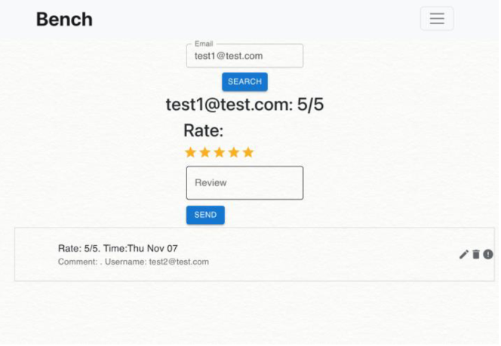

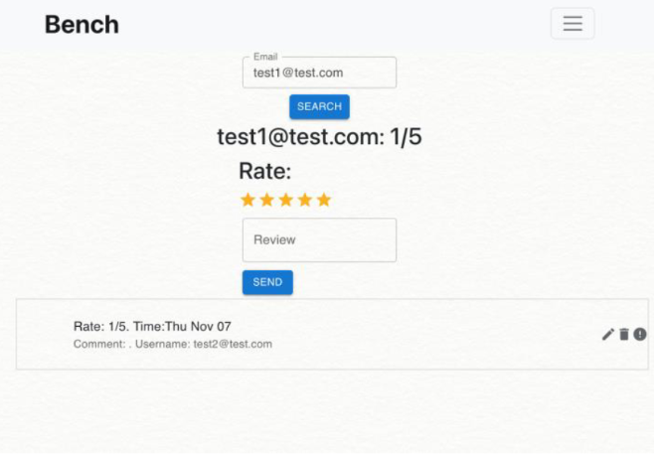

**Test 2**

1. Start the Bench application.
2. Click the button “Login” on the navigation bar.
3. Enter the email “team23project@gmail.com” into the text field labeled “Email address”.
4. Enter the password “12345678” into the field labeled “Password”.
5. Click the button “Login” below the field.
6. Open the review page using the review button on the profile page.
7. Search for a user you gave a review to in the search bar
8. Click the delete button on the showing review that was given by you
9. Delete the review and then submit

**Expected Result:** The review given by the user should be deleted



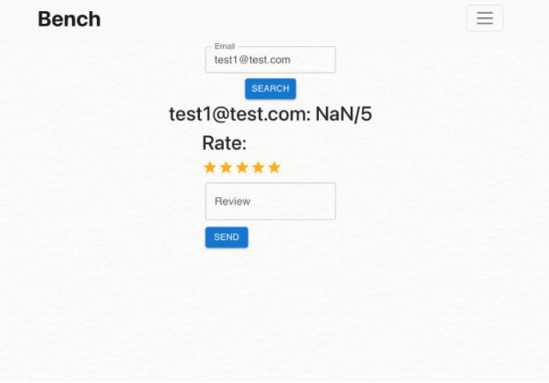

**Test 3**

1. Start the Bench application.
2. Click the button “Login” on the navigation bar.
3. Enter the email “team23project@gmail.com” into the text field labeled “Email address”.
4. Enter the password “12345678” into the field labeled “Password”.
5. Click the button “Login” below the field.
6. Open the review page using the review button on the profile page.
7. Search for a user you did not give a review to in the search bar
8. Click the edit/delete button on the showing review

**Expected Result:** The user should not be able to delete/edit a review left by another user

